**COM109 Practical Skills Assessment**

**Practical Assessment 1**

**Assessment Title: Coffee Corner**

**Author: Student Number B00812794 (Keith Edgar)**

Contents

1. Initial Wireframe Design 3
2. Colour Scheme Selection 4
3. Design process 4
4. Basic Structure 4
5. Header 5
6. Animated Navigation Bar 5
7. Footer 5
8. Background 6
9. Home Page Main Section 6
10. About Us Page Main Section 6
11. Contact Us Main Section 7
12. Gallery Page Main Section 7
13. CSS and HTML Validation Screenshots 8
14. References 9

# Initial Wireframe Design

Footer containing copyright information.

Animated navigation bar

A bit about the business

Quick links to home page and contact us page.

Essential contact us information

Article 1

Section on why you should visit Coffee Corner.

Article 2

Header

# Colour Scheme Selection

When deciding upon my colour scheme I made the decision that I would work on my logo to see what colours would be involved in that to form the basis of my colour scheme. In doing do I found that the logo consisted of greys, orange tones and white which I have made use of each colour for different sections. I have used black for all main text which I feel was then easiest to read for the user and was most recognisable for general text. I used orange for the text in the header and the navigation menu because these were more important pieces of text that should be made to stand out compared to the rest of the text and I chose the orange font colour because this matched in with the theme of the cup in the logo because that I also orange and ties I well in comparison. I then used dark grey for the background colour of the header, footer and the navigation menu because they help to make them stand out and look well by using them as a form of closure in the webpage (used these colours for both the top and bottom of the webpage). I used lighter shades of grey for the text in the main container of the webpages because I thought that the greys would be a good colour scheme as in the logo, once again, the background is consisting of grey tones and I feel that this works well in comparison. I feel that using these colours have helped to make the webpage feel very professional as well as allowing a cosy, welcoming feeling as everything in the webpage matches in.

In the contact form you can see that I made use of white text fields and used white in the animation of the menu when you hoover over a tab. I done this because again it is a colour that is in the logo (white inside to the cup helping to show how the contact form is sending a message inside the company just like the colour shite is inside the cup).

# Design process

When beginning my design process, the first step was to decide the colour scheme that I was going to go for and to do this I needed to decide upon a logo. The logo I choose was off a coffee cup that is tipped over and spilling coffee beans to represent my coffee themed website which was my go-to idea from the beginning. From this I then formed my colour scheme, which can be seen on the previous page, based on the colours that were included in the logo (orange, white, black and greys).

## Basic Structure

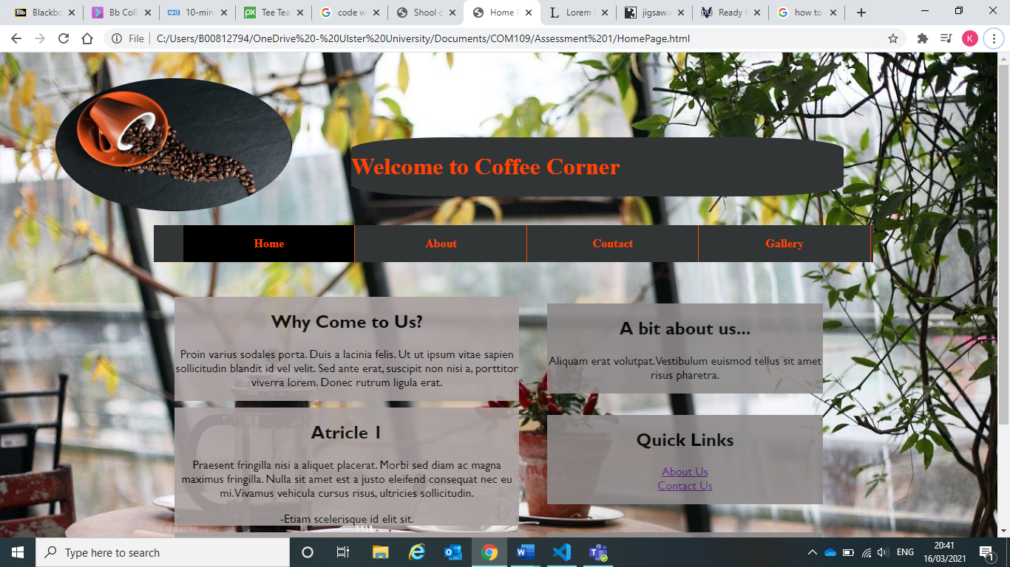

As seen through the screenshot above, the basic structure of my webpages is consisting of a logo, header, negation menu and background image on all webpages. These four things are all the same on every webpage and are all positioned in the exact same way on every webpage to add consistency and give that more professional look. As seen in the screenshot below all webpages have a footer that contains the same information on every webpage, has the same width and is always positioned at the bottom of the webpages.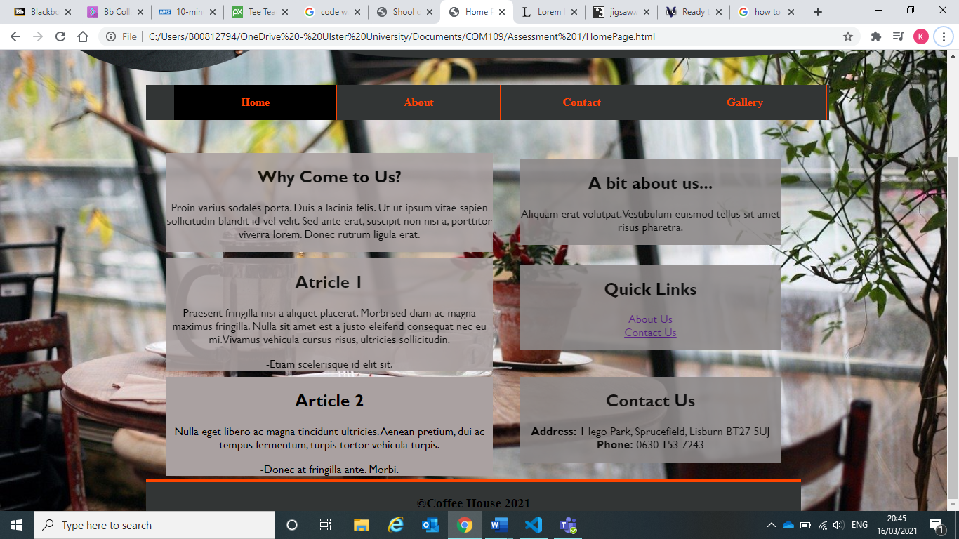

## Header



The header was designed using a border radius of 20% to give it that rounded effect to make it stand out from the rest of the page as it is the header. I coloured it orange red to fit in with the colour scheme.

## Animated Navigation Bar



The navigation bar consists of links to each of my webpages to allow users to switch from webpage at each. There is a border of 1px coloured orange red to give it a more separated effect for each link on the webpage. When hoovered over the link turns white and when clicked turns black to show what webpage the user is on.

## Footer



The footer is positioned at the bottom of each webpage. It is made up using a dark grey background colour and a top solid border of 4px which is coloured orange red to match the theme and help it stand out as being a footer for the webpage.

## Background

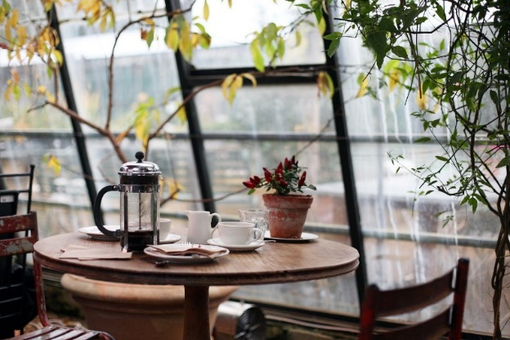

The background image is of a coffee shop table that include the colours that are in the logo to hep match the theme but also some other brighter colours which help to make it easier for the users to read the text throughout the actual webpages.

## Home Page Main Section

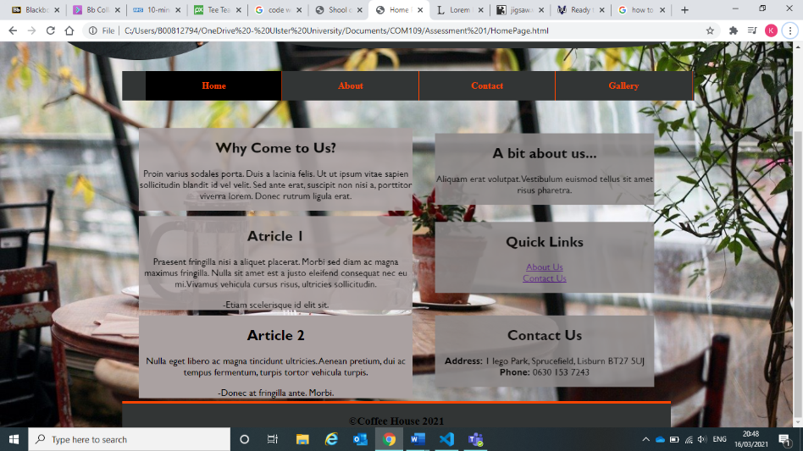

The Home page has 6 different containers which each have very different information and varying sizes. Each of these 6 containers have an opacity of 90% to allow the background image to be seen behind them slightly to help them look more professional and readable. In the quick links section, there are links to the about us page and contact us page work when clicked.

## About Us Page Main Section

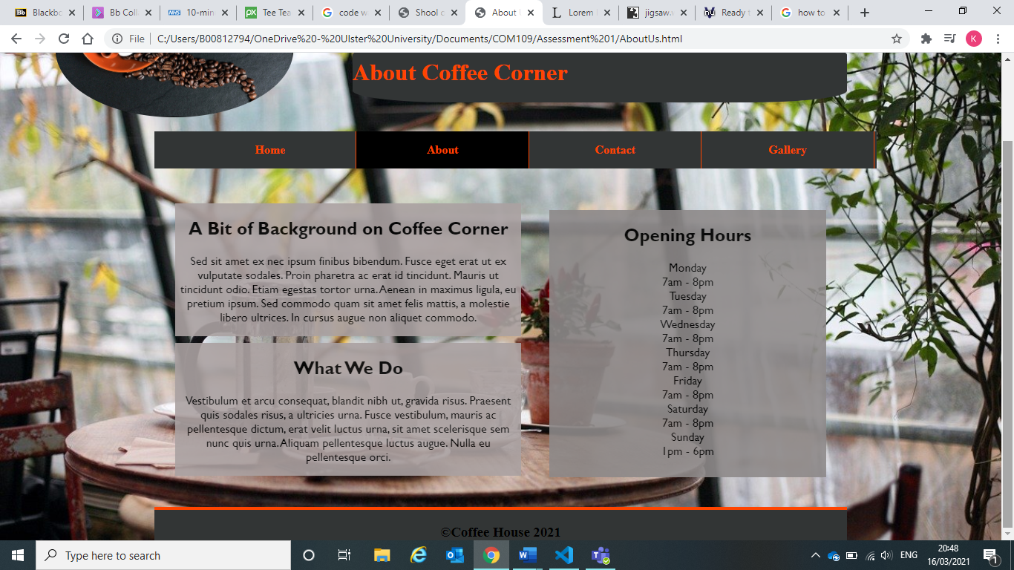

The About Us page has three different containers which each have very different information and varying sizes. Each of these three containers have an opacity of 90% to allow the background image to be seen behind them slightly to help them look more professional and readable. In the quick links section, there are links to the about us page and contact us page work when clicked.

## Contact Us Main Section

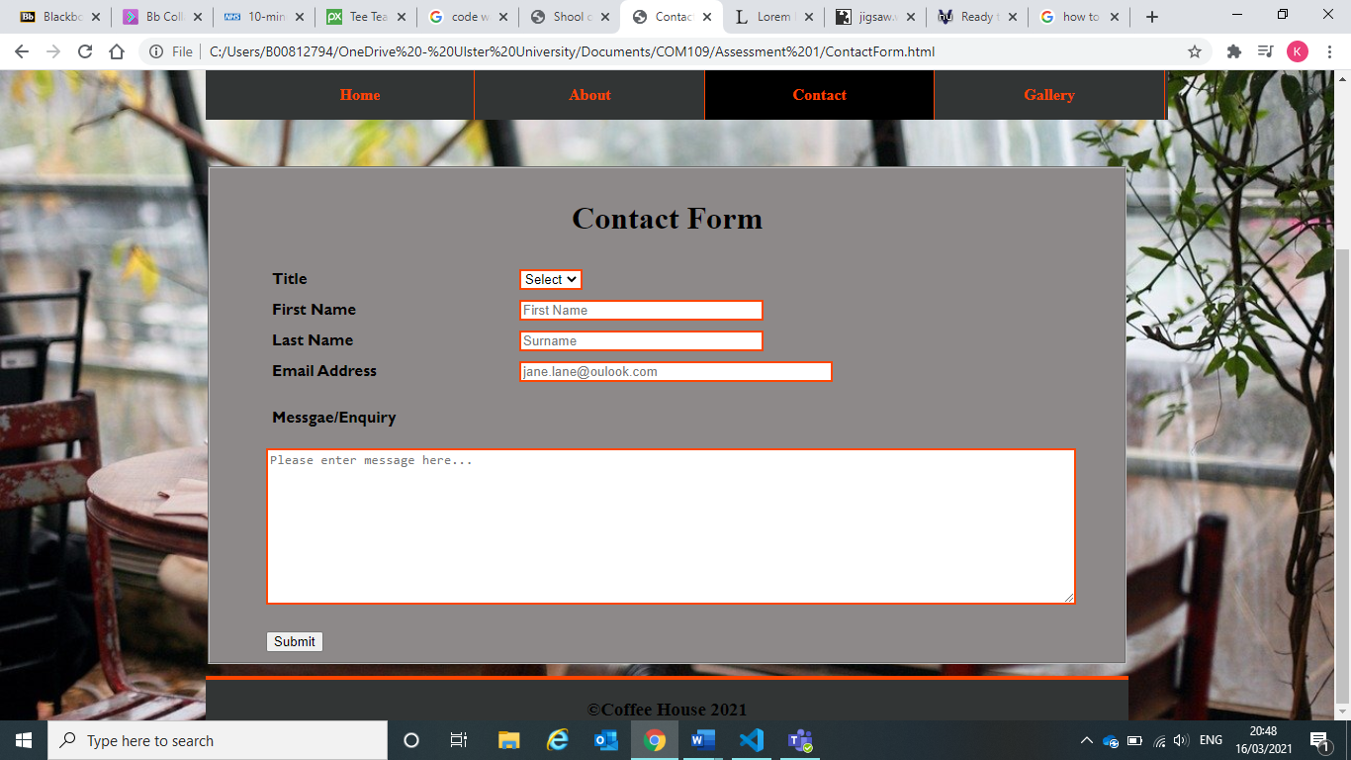

The Contact Us page has a contact us form which is made up of a field set that has a select entry and four input entries; each of which all have validation criteria to help ensure that the data entered is correct and suitable. There is then a pop up (alert) window summarising all the input data which resets the contact form once it has been closed. White background colour has been used for the input fields to help make it easier to read which you have just entered and matches the colour scheme. The submit button is made up of jQuery to give it that button classification that produces the summary of data once again to help make it more professional and accessible.

## Gallery Page Main Section

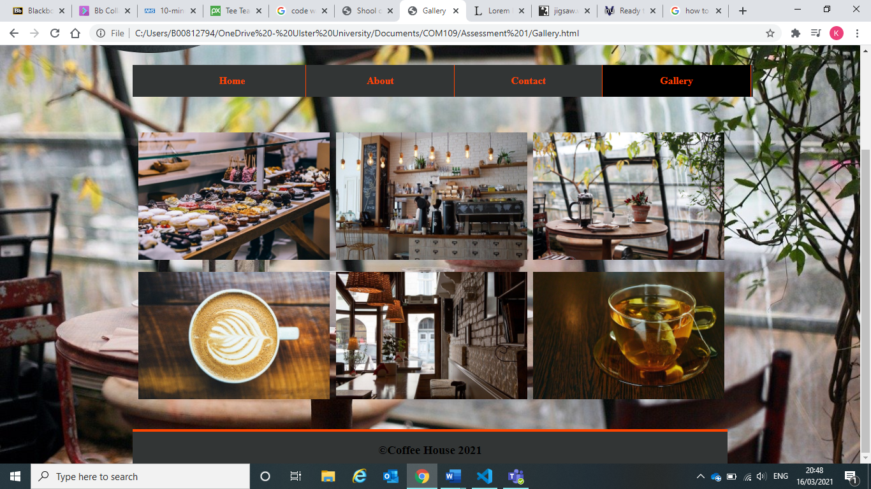

The Gallery consists of 6 images which are displayed evenly across the webpage. There are all relating to the theme of coffee shops and each have a width of 300px and a height of 200px. They also have a left, bottom and top margin of 1% to help spread them out evenly.

# CSS and HTML Validation Screenshots

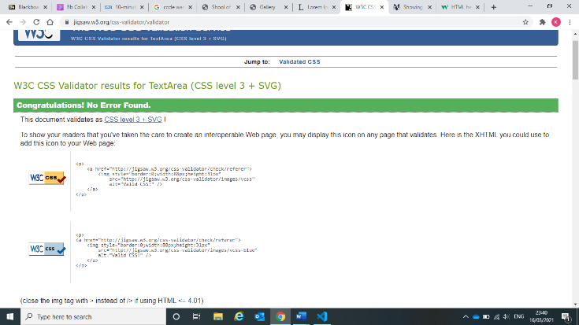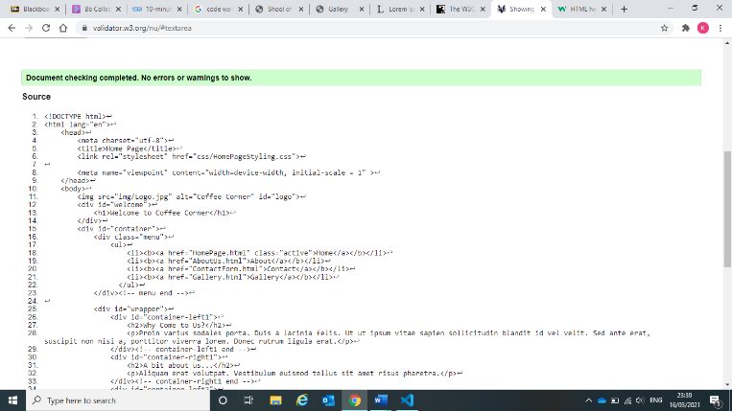**Home page**

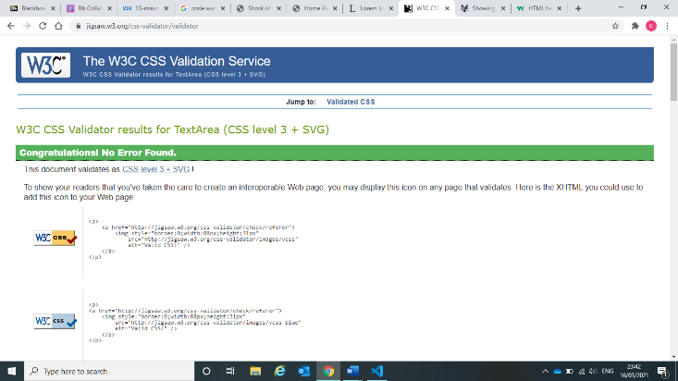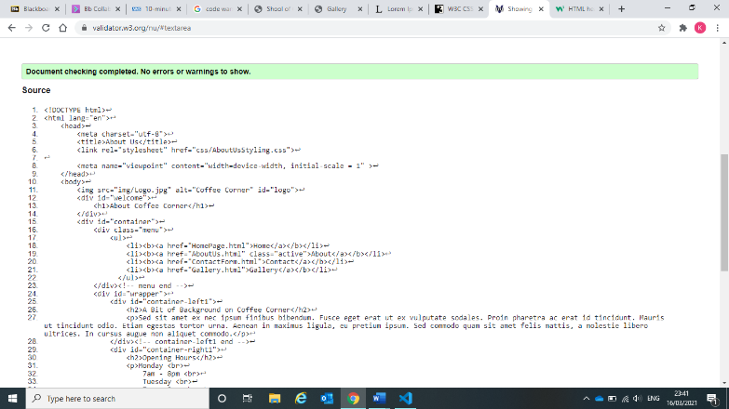**About Us page**

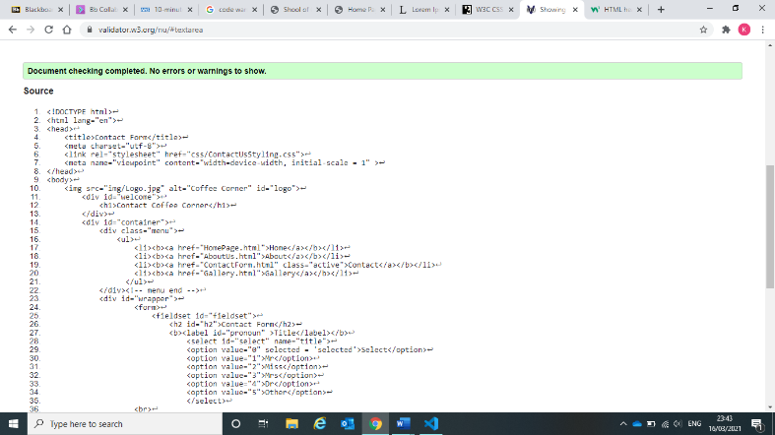**Contact Us page**

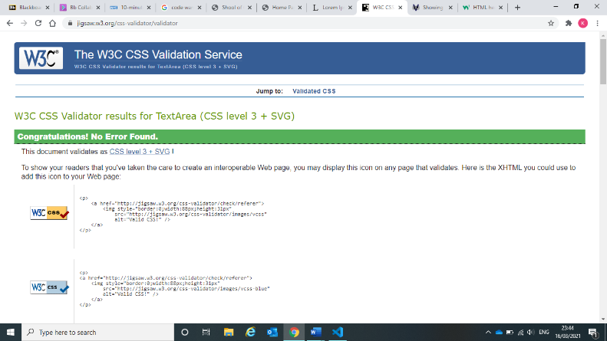

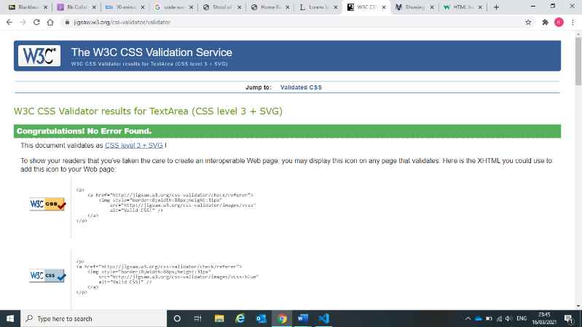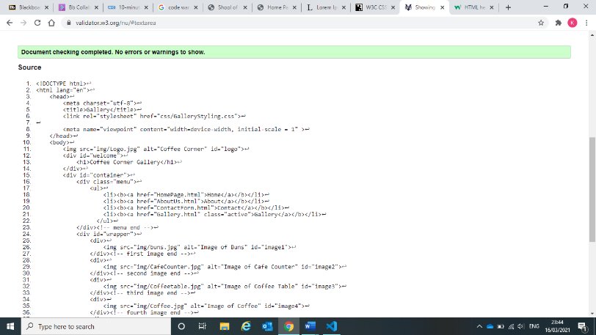**Gallery page**

# References

<https://www.lipsum.com/>

<https://jigsaw.w3.org/css-validator/#validate_by_input>

<https://validator.w3.org/nu/#textarea>

<https://pixabay.com/>

<https://www.w3schools.com/howto/howto_js_topnav.asp>

<https://www.w3schools.com/howto/howto_css_images_side_by_side.asp>